Game Design Document

Fill up the following document

1. Write the title of your project.

Unicorn Explorer

1. What is the goal of the game?

To get as many points as the unicorn can get.

To not hit any obstacles.

1. Write a brief story of your game.

The Unicorn is in “Candy Land” and it wants to explore the land but there are obstacles in the way and the unicorn needs help jumping over the obstacles.

1. Which are the playing characters of this game?

* Playing characters are the ones who respond to the user based on the input from the user.
* Cars, monkeys, dinos, wizards, etc., are the playing characters in the game.

|  |  |  |
| --- | --- | --- |
| Number | Character Name | What can this character do? |
| 1 | Unicorn | The Unicorn can jump over the obstacles every time we press the space button on out keyboard. |
| 2 |  |  |
| 3 |  |  |
| 4 |  |  |
| 5 |  |  |
| 6 |  |  |
| 7 |  |  |
| 8 |  |  |

1. Which are the Non-Playing Characters of this game?

* Non-Playing characters are the ones that don't have an action or behavior when the user interacts with the game.
* Hurdles, stones, bananas, coins, etc., are non-playing characters in the game.

|  |  |  |
| --- | --- | --- |
| Number | Character Name | What can this character do? |
| 1 | Poisonous bushes | Can hurt the unicorn |
| 2 | stones | Can block the way of the unicorn |
| 3 |  |  |
| 4 |  |  |
| 5 |  |  |
| 6 |  |  |
| 7 |  |  |
| 8 |  |  |

Draw your imagination of this game. What does this game look like?

* Draw the game either on your computer or on paper.
* Add images of the game scenes to show each of the playing and non-playing characters at least once.

How do you plan to make your game engaging?

I can make it engaging by putting a fun background and making the charectars look more fun and attractive.

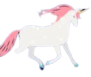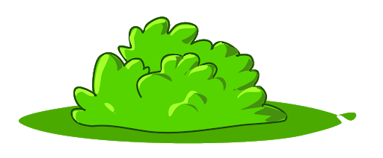 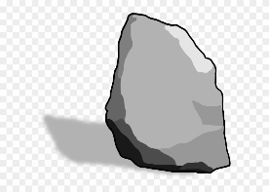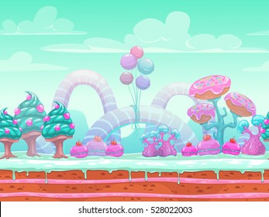

NOTE: For some reason I can’t put the images on the background in this word document so that’s why I put them on top. Also, these aren’t the exact images I am going to use because I have to edit my images that I will use but this is what I’m planning to make it like. (I MIGHT use these images if they look nice and I am using this background until further notice)

* The player will play on a laptop/desktop.
* I will make my game in vs code.